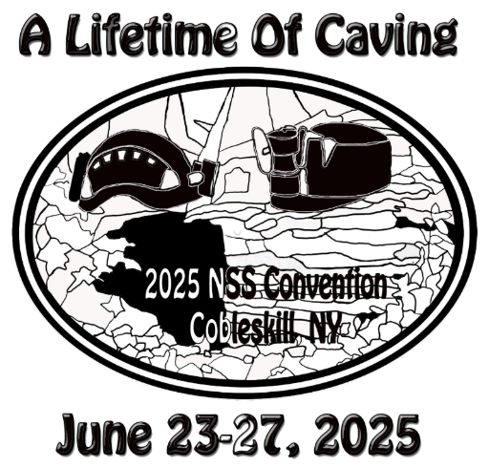
2025 National Speleological Society (NSS) Convention
LOCAL SPONSORS
Information Sheet

Please complete this form with the business information exactly as you would like it to appear on the Local Sponsors handout. Please print clearly.

Business Name _______________________________________________________________
Business Type (Dining, Activities, Shopping, Lodging) _________________________
Discount being offered: __________________________________________________________________
Business Address ___________________________________________________
___________________________________________________
___________________________________________________
Business Email Adress _____________________________________________________________________

Please complete the following:
Contact Person _______________________________________Phone Number ____________________
Contact Email ___________________________________________________________________________
Would you like your business card printed in the Convention Program? □ yes □ no

Additional Sponsorship Opportunities: □ ¼ page ad - $100 □ ½ page ad - $350
Payment Received: □ yes □ no Check # ___________ Bank Name ____________________________
Received by: _________________________ Date _________________

Look for an email from Leslie Hatfield, 2025 NSS Convention Sponsorship Chair. A Program Ad Specs sheet will be emailed to the contact person listed above. The deadline for ad submission is 4/1/2025.
Deadline extended to May 1st!

